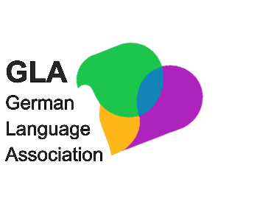
Symposium und Gründungsveranstaltung der GLA
Deutscher Sprachunterricht an britischen Universitäten:
Vergangenheit, Gegenwart, Zukunft
10. September 2025
King’s College, London
Vorläufiges Programm (Änderungen vorbehalten):
9.30 – 10.00 Anmeldung und Erfrischungen
10.00 - 10.30 Eröffnung und Grußworte
10.30 - 11.30 Keynote Professor Nicola McLelland, title tbc
11.30 - 12.15 Initiativen und Projekte für Deutsch in UK HE
12.15 - 13.00 Workshop: Chancen, Herausforderungen und Kollaboration für DaF-Lehrende
13.00 – 14.00 Mittagessen
14.00 – 14.30 AGM
14.30 – 15.30 Beiträge zu einzelnen Themenbereichen
River room | Room tbc
Christiane Günther, Swansea University  Crossing Campuses, Creating Brands: An Action-Oriented Approach to German Language Learning through Inter-University Collaboration | Kristina Notthoff, University of Nottingham  Make Content Great (Again) - Verstärkter Einsatz von themenzentriertem Inhalt im Sprachunterricht.
Mandy Poetzsch, University of Bristol  AI as the Future of Language Teaching | Angelique Arts, King’s College London  Collaborative Escape Room Design
15.30 – 16.00 Kaffee und Networking
16.00 – 16.30 Abschließende Diskussion am Runden Tisch
The event is supported by the DAAD and the Goethe Institute.
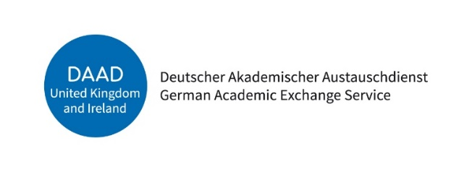

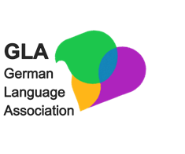
Symposium and inaugural meeting GLA
Deutscher Sprachunterricht an britischen Universitäten:
Vergangenheit, Gegenwart, Zukunft
10th September 2025
King’s College, London
Preliminary Programme (subject to change):
9:30 – 10:00 Registration and refreshments
10:00 – 10:30 Opening and Welcome Addresses
10:30 – 11:30 Keynote: Professor Nicola McLelland, title tbc
11:30 – 12:15 Workshop: German in the UK – Initiatives and Projects
12:15 – 13:00 Opportunities, challenges and collaborations for GfL teachers
13.00 – 14.00 Lunch
14:00 – 14:30 Annual General Meeting (AGM)
14:30 – 15:30 Presentations on Specific Topics
River room | Room tbc
Christiane Günther, Swansea University  Crossing Campuses, Creating Brands: An Action-Oriented Approach to German Language Learning through Inter-University Collaboration | Kristina Notthoff, University of Nottingham  Make Content Great (Again) - Verstärkter Einsatz von themenzentriertem Inhalt im Sprachunterricht.
Mandy Poetzsch, University of Bristol  AI as the Future of Language Teaching | Angelique Arts, King’s College London  Collaborative Escape Room Design
15:30 – 16:00 Coffee and Networking
16:00 – 16:30 Concluding Round Table
The event is supported by the DAAD.
